kubectl get replicasets

**Create a Deployment file**

vim anil.yaml

apiVersion: extensions/v1beta1

kind: Deployment

metadata:

name: nginx-deployment

spec:

replicas: 4

template:

metadata:

labels:

app: nginx-app

spec:

containers:

- name: nginx-container

image: nginx:1.7.9

ports:

- containerPort: 80

**Deploy the resources**

kubectl create -f anil.yaml

kubectl get replicasets

kubectl expose deployment nginx-deployment --type="LoadBalancer"

kubectl get pods

NAME READY STATUS RESTARTS AGE

nginx-deployment-64bb5667f-7p74g 1/1 Running 0 2m

nginx-deployment-64bb5667f-gb9fs 1/1 Running 0 2m

nginx-deployment-64bb5667f-h7f2p 1/1 Running 0 2m

nginx-deployment-64bb5667f-m8qvs 1/1 Running 0 2m

kubectl describe pods -

Notes :

Controlled By: ReplicaSet/nginx-deployment-9dfcd7d77

Observer see the verison of images used : 1.7.9

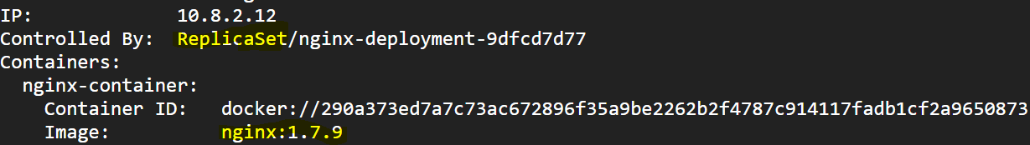

**Create v2 deployment file**

vim anil2.yaml

apiVersion: extensions/v1beta1

kind: Deployment

metadata:

name: nginx-deployment

spec:

replicas: 4

template:

metadata:

labels:

app: nginx-app

spec:

containers:

- name: nginx-container

image: nginx:1.9.1

ports:

- containerPort: 80

cp anil.yaml anil2.yaml

kubectl rollout history deployment nginx-deployment

kubectl apply -f anil2.yaml --record

kubectl rollout history deployment nginx-deployment

kubectl get pods

NAME READY STATUS RESTARTS AGE

nginx-deployment-9dfcd7d77-k7z5l 1/1 Running 0 1m

nginx-deployment-9dfcd7d77-nfx4q 1/1 Running 0 1m

nginx-deployment-9dfcd7d77-prc9h 1/1 Running 0 1m

nginx-deployment-9dfcd7d77-w2j65 1/1 Running 0 1m

kubectl describe pods nginx-deployment-9dfcd7d77-k7z5l

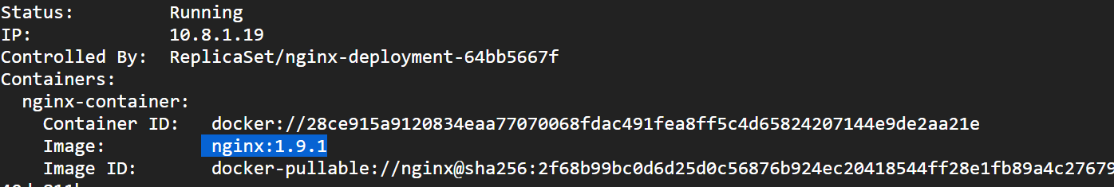

kubectl get rs

NAME DESIRED CURRENT READY AGE

nginx-deployment-64bb5667f 4 4 4 4m

nginx-deployment-9dfcd7d77 0 0 0 13m

kubectl rollout undo deployment nginx-deployment

kubectl get rs

NAME DESIRED CURRENT READY AGE

nginx-deployment-64bb5667f 0 0 0 5m

nginx-deployment-9dfcd7d77 4 4 4 14m

kubectl get pods

NAME READY STATUS RESTARTS AGE

nginx-deployment-9dfcd7d77-4jkz5 1/1 Running 0 59s

nginx-deployment-9dfcd7d77-8xgg2 1/1 Running 0 58s

nginx-deployment-9dfcd7d77-qcpp6 1/1 Running 0 59s

nginx-deployment-9dfcd7d77-w6b9z 1/1 Running 0 58s

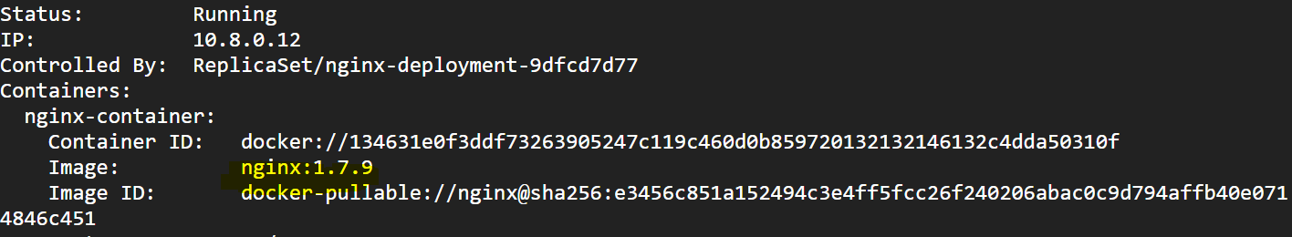

kubectl rollout history deployment nginx-deployment